


Health in Design of Industrial Facilities

Technical Guideline

Table of Contents
1. Purpose and scope 3
2. Management process 4
2.1 Management of working environment in projects 4
2.2 Hierarchy of control 5
3. Health Risk Assessment (HRA) 5
3.1 Introduction 5
3.2 Risk identification of health hazards 6
3.3 Risk assessment 6
3.4 HRA in project phases 7
4. Project tasks for working environment hazards 10
4.1 Activities in the different project phases 10
4.2 Noise and vibration 14
4.3 Ergonomic health risk, material handling 17
4.4 Chemical exposure 19
4.5 Biological hazards 22
4.6 Illumination and daylight 24
4.7 Indoor and outdoor climate 25
4.8 Radiation 26
Annex A HRA (excel) 27
Annex B Risk Assessment Methods 27
Annex C Norwegian Regulations 29
Summary of where regulations impact working environment factors 29
Regulations 32
Consent applications 34

Purpose and scope

Norsk Industri recognises the need for providing clear and practical guidance to ensure that health and working environment considerations are effectively integrated into design processes of industrial facilities.

This document sets out guidelines for systematically embedding health considerations into the design processes. Its objective is to support the elimination or control of workplace health hazards and risks during the design phase. It also provides guidance on when and how to engage specialist health expertise at key design stage gates.

The greatest value in addressing health during design is the ability to influence the development of processes, equipment and structures in ways that promote a safer and healthier workplace. By identifying and controlling the sources and root causes of potential health risks at the design stage, organisations can significantly limit the need for costly mitigation measures during operations.

The target audience includes all stakeholders involved in designing or modifying industrial facilities on the Norwegian mainland - owners, project organisations and contractors.

The procedures outlined in this guidance may serve as a component of the documentation required for submission to the Norwegian Labour Inspection Authority during the building permit application process.

This document does not address health hazards during construction or commissioning, nor does it cover psychosocial hazards or technical, organisational or process safety.

Management process

Management of working environment in projects
During the design of new facilities or modifications, it is important that any working environment issues are identified as early as possible. This requires good cooperation and involvement between users, working environment experts, occupational health services, design engineers, safety delegates and employee representatives.

To ensure a fully satisfactory working environment in operation, working environment management needs to be integrated in the wider project management and milestones should include the following:

- Identification of working environment requirements
  - establishment of project design requirements, see Chapter 4 for guidance.
- identification of health hazards related to work tasks/activities.
  - A general health risk assessment, HRA, is described in Chapter 3.
  - Detailed risk assessment methods are described Annex B Risk Assessment Methods.
- control of the health risks in design in accordance with the project requirements
  - the hierarchy of control shall be followed as described in Chapter 2.2.
  - cost benefit analysis of design options shall be documented to ensure compliance with project design requirements. The As Low As Reasonably Practicable (ALARP) principal can be used for this purpose.
  - Client approval of cost benefit analysis
- project deliverables for the different stages of projects are described in Chapter 4.
  - description of project deliverables
  - guidance on project requirements
  - suggested verification activities.

Hierarchy of control
The hierarchy of control is a structured approach used to manage risks in the workplace. It ranks control measures from the most effective to the least effective, providing guidance in reducing exposure to hazards.
Control of health risks shall follow the hierarchy of control provided in Figure 1.
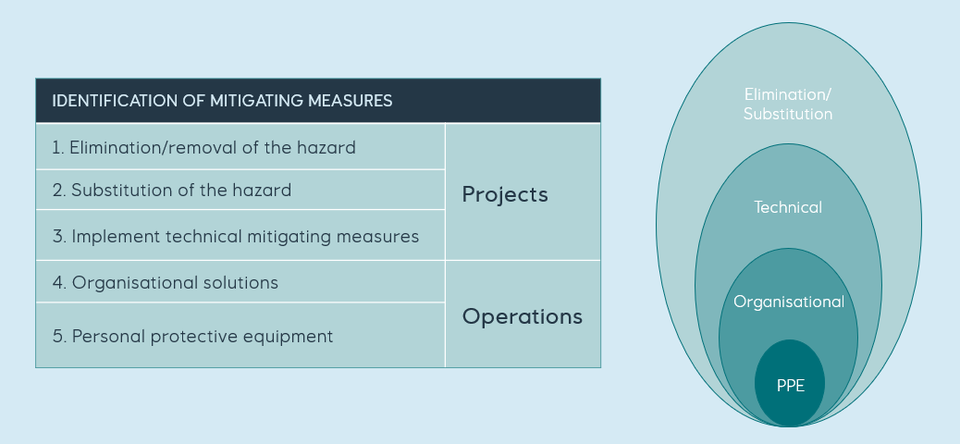
Figure 1 Hierarchy of control of health risks.

Health Risk Assessment (HRA)

Introduction
The objective of this section is to provide an appropriate and recognised method to identify health hazards, to assess the health risks for workers in connection with their work task and to propose risk reducing actions. This method is suitable both for development of new projects and for modification projects.

The HRA is conducted in each project phase from feasibility to detail engineering, see Table 2 for phase descriptions. For a project, the aim of the HRA is to identify and reduce occupational health risks through design solutions of the contract object (i.e., elimination, substitution and/or engineering technical controls). The project should always aim to secure an acceptable working environment for the future workplaces in the operational phase.

HRA is a general and qualitative risk assessment method. Some additional HRA characteristics are:
- The health hazards and exposure related to work tasks/activities are identified.
- The risk of health effects that may occur after a prolonged exposure or develop a long time after the first exposure is the focus.
- The outcome is an overview of risks and their mitigations relevant to preventing work-related illness.
- Identification of the need for detailed risk assessments.

Risk identification of health hazards
The hazards related to the working environment are grouped into defined categories. The following hazards should be assessed in the HRA:
- Chemicals and dust
- Ergonomics
- Noise
- Biological
- Vibration
- Illumination
- Radiation
- Climate / Temperature
- Pressure gradients / Oxygen pressure

In the multidiscipline workshop, identify all health hazards related to each work activity by using brainstorming techniques and/or check lists. Each work activity may have several health hazards.
Description of WE factors, examples of hazards, endpoints and guidewords for HRA workshops are given in Annex A HRA (excel). The list of guidewords may be adapted to the scope by adding or replacing keywords.

Risk assessment
There are many different factors influencing the risk level of a task, depending on the type of hazard. The frequency and duration of the task is always important to assess. The planned maintenance interval for a certain piece of equipment and the total number of such equipment is another input. It is also important to assess the manning level and the maintenance philosophy and how these may affect the work environment exposure. Table 1 HRA risk matrix shows the HRA risk matrix with detailed recommendations for setting risk level and proposing mitigations for projects. Please be aware that the risk levels are set based on health effect risks.
Table 1 HRA risk matrix
The HRA risk matrix
Ranking | Colour | Description | Details | Guidance
0 |  | Not assessed or unknown | The WE factor is not relevant or unknown or for other reasons not assessed | No action is needed in this phase. This may change as the design matures and optimises
1 |  | The risk is low and acceptable | The health risk of relevance to work-related illness is well controlled through design solutions. | There is no need for project design changes at this stage.
2 |  | The risk is medium | The health risk of relevance to work-related illness is adequately controlled through design solutions. | Feasibility / Concept / FEED:  ALARP and further optimisation during project maturation.  Detailed design:  ALARP and optimisation during project maturation.  Hand-over to operations:  Maintain medium risk level (yellow) if WE risk of design is tolerable and agreed to be controlled in operations through organisational measures and/or additional PPE.
3 |  | The risk is high or unacceptable | The health risk of relevance to work-related illness is not controlled through design solutions. | Actions and changes are needed in the current design to reduce risks.  The risk should be reduced through design solutions by elimination or reduction of hazard and/or likelihood/exposure through substitution or technical solution.

HRA in project phases
The details studied in the HRA process increase with the maturity of the project and as accuracy of the risk knowledge increases. What to focus on in the various project phases are shown in Figure 2. A description of the project phases is available in Table 2.
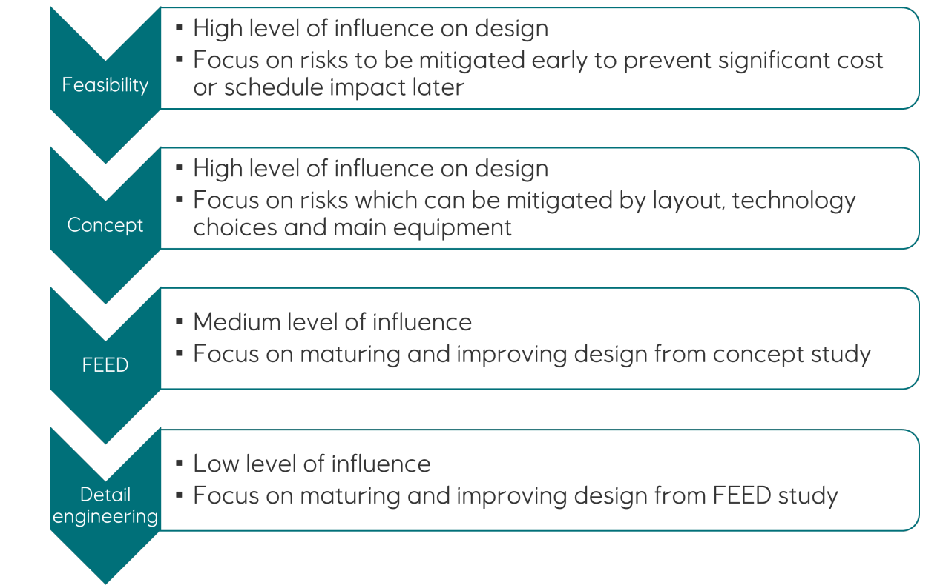
Figure 2 HRA focus areas through the project phases

Feasibility / Concept
A simplified HRA should be performed in the early phase of a project and when concept(s) are developed. See suggestion for an early phase HRA template in Annex A HRA (excel) and Figure 4.

Front End Engineering Design (FEED) / Detail engineering
In the FEED and detailed phase, the HRA method’s main steps shown in Figure 3 are:
- Planning and preparation of workshop including description of work activities.
- Identification of hazards and frequency of exposure in workshop.
- Evaluate the need for detailed risk assessments, see Chapter 4.
- Qualitatively assessing risk level and propose risk reducing actions in workshop.
- Documentation of assessment and actions, see suggestion for a template in Annex A HRA (excel), Figure 3 and Figure 5.

Figure 3 Flow chart of HRA in the FEED phase
The HRA method includes multidiscipline workshops for health risks assessment of work tasks/activities performed and can be organised based on job category or on the area (specific location) where the work is performed.

Input from the following strategies and philosophies are important:
- Operational strategy
- Automation strategy
- Material handling strategy
- Maintenance and cleaning philosophy
- Manning philosophy

The following project members should take part and contribute:
- Operations work representatives
- Maintenance and janitorial representatives
- Technical/engineering discipline (mechanical, process, layout, piping, material handling, technical safety)
- Working environment experts / occupational health service including physiotherapists, occupational hygienists, toxicologists and specialists in occupational medicine.
- User representatives / safety delegates

More detailed risk assessments may be required where the HRA identifies medium, high or unacceptable risks. Guidance on detailed risk assessment methods are provided in Annex B Risk Assessment Methods.

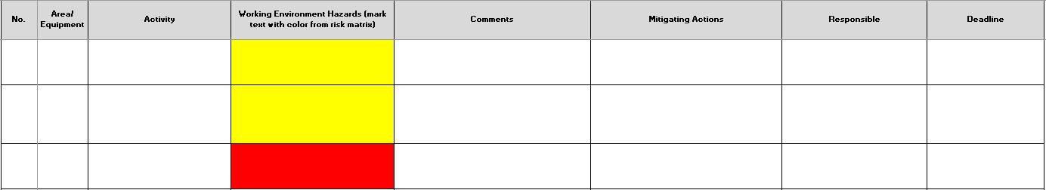
Figure 4 Early phase HRA template screenshot

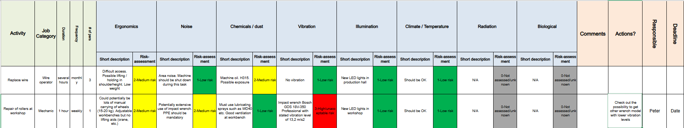
Figure 5 HRA template screenshot

Project activities

Activities in the different project phases
There are several different project execution models that are employed in Norway. A summary of the main project activities and deliverables related to working environment is presented in Table 2 for an example of project execution models.

Table 2 Summary of working environment evaluations and deliveries per project phase
Phase | Purpose | Description of working environment evaluations | Required input | Deliverables
Feasibility | To determine whether the project is viable.  Key Activities: Technical assessments, cost estimates, risk analysis, regulatory reviews.  Outcome: A go/no-go decision based on whether the project is technically and economically feasible from an HSE perspective. | The early phase high level HRA workshop aims to find the working environment risks that are showstoppers and that have a significant cost or schedule impact if the mitigation of these is addressed at a later stage in the project maturation.  For this early phase, typical risks and mitigations from similar facilities and projects should be assessed for relevance.  Examples of issues to assess include technology selection with regards to noise, hazardous chemicals and dust, main layout with regards to access, material handling and noise control measures. | Site selection and main layout  Main system design and technology selection | Early phase HRA  Overall technology assessment
Concept selection | To define the project’s scope and strategic direction.  Key Activities: Development of initial design options, selection of preferred concept, stakeholder alignment.  Outcome: A conceptual design and project definition that sets the foundation for further engineering. | The focus of the early phase HRA should be on the process, the main layout, the main equipment, and their consequences for WE risks in operation. Identified risks should result in input to concept selection and mitigating actions in design at this early phase.  Working environment input to system, layout, technology selection and concept selection processes with a focus on cost drivers.  Input to strategies for automation, material handling and ventilation. | Manning philosophy  Automation strategy  Material handling philosophy  Basic layout | Early phase HRA  Input to concept selection  Identification of regulatory requirements relevant for the project.  Overall technology assessment
FEED | To develop the technical basis for project execution and investment decisions.  Key Activities: Detailed design of major systems, main layout, cost and schedule estimates, procurement planning.  Outcome: A comprehensive design package used for final investment approval and tendering. Vendors have typically been contacted but no purchases have been made. | Working environment expertise shall be an integrated part of the project team and participation in project reviews including system and layout reviews.  The detailed HRA should enable a thorough review and contribute to the ongoing process of mitigating WE risks through design. Description of administrative (organisational, e.g., procedures) and personal mitigations (e.g., PPE, training) should not be part of the actions in this project phase. Detailed risk assessments and studies shall be performed based on identification of need in the HRA.  Access and material handling solutions.  Working environment requirements shall be identified as input to the purchase of equipment.  At the end of the FEED or the start of Detail, the consent application to the Norwegian Labour Inspection Authority and the building application are submitted. | Operational strategy  Automation strategy  Material handling strategy  Maintenance and cleaning philosophy  Manning philosophy  System design  Layout | Detailed HRA  Detailed risk assessments  Input to requirements specification for equipment suppliers  Identification of work operations with chemical exposure, technical solutions, working atmosphere etc.  Documentation for inclusion in consent application and building application
Detail Design | To finalise all technical specifications and prepare for construction and commissioning.  Key Activities: Creation of construction drawings, equipment specifications, integration plans.  Outcome: Ready-to-build documentation and instructions for contractors and suppliers. | The HRA should be performed in the first few weeks of the detail engineering phase and be based on the FEED HRA and the further maturation of the design. Actions will include the need for detailed risk analysis and studies, and the results of detailed studies should be included in risk level update/action close-outs later in the detail engineering phase.  The close-out descriptions for the final update of a project HRA should include the actual risk status by design and an overview of unsolved actions and the total working environment workload per job category and shift.  The responsibility to approve the results of the design and ensure further mitigations (e.g., procedures, training, PPE) lies with operations.  Working environment requirements shall be identified as input to the purchase of equipment. Follow up of purchase of equipment. |  | Detailed HRA  Detailed risk assessments  Health risk status for each job category  Input to requirements Specification for equipment suppliers  Documentation for inclusion in consent application and building application
Construction and Commissioning | To build and test the facility or system.  Key Activities: Site preparation, civil works, mechanical/electrical installation, system testing, performance verification, safety checks.  Outcome: Completed infrastructure, commissioning reports, handover documentation | Verification of lighting, ergonomics and chemical exposure.  For residual exposure risks, the need for organisational safety measures (e.g., changes in the permit-to-work systems, instructions/training) and/or use of personal protective equipment shall be identified for implementation by operational procedures. |  | Verification report  Residual risk and need for operational risk mitigation measures
Operation | To operate and maintain the asset to deliver intended value. | Verification of noise  For residual exposure risks, the need for organisational safety measures (e.g., changes in the permit-to-work systems, instructions/training) and/or use of personal protective equipment shall be identified for implementation by operational procedures. |  | Verification report  Residual risk and need for operational risk mitigation measures

Noise and Vibration

Project deliverables
Guidance on noise is given by the Norwegian Labour Inspection Authority, Støy.
The main noise control engineering project deliverables are outlined in Table 3. A design procedure is also given in ISO 15664:2026 Noise control design procedures for open plant.
Table 3 Noise control engineering - recommended project deliverables
Noise control engineering – Recommended project deliverables
Feasibility | Normally environmental noise considerations only
Concept | Concept noise study report  Identification of the main governing noise requirements and specific project challenges with regard to noise.  Identification of main noise sources (mechanical equipment, flow generated noise, electromagnetic noise sources),  Identification of main noise control measures likely to be required (noise enclosures, machinery rooms, noise barriers, large noise attenuators, low noise solutions)  Defined area noise limits for each room and area.
FEED / Preparation for execution | Noise allocation report  Noise limits and estimate for noise control measures needed.  Identification of noise sources and predictions of area noise levels, possibly using noise simulation software.  Identification of vibration sources.  Determining the equipment noise limits and expectations to suppliers and subcontractors. Review supplier noise data. Establish noise data sheets ready for procurement where applicable.
Detailed Engineering  Execution | Noise control report  Predicted area noise levels.  Noise data sheets for equipment, and outlining the necessary noise control measures needed.  Follow up suppliers to confirm that they can deliver within the specified noise requirements, using ALARP-principles. Suppliers with options for intrinsic low noise equipment shall be preferred.  Noise input to design review.
Construction/ Commissioning | Noise verification report documentation of noise measurements, ref. NS 4814 and NS 4815.
Operation | Post-installation verification: conduct final inspections and verification measurements to ensure the installed installation meets the noise requirements, using NS 4814 for area noise measurements and noise maps.  Noise and vibration exposure risk assessments using the nominal exposure time and measured noise level for each area and the actual attenuation from personnel hearing protection (measurements of PVP sound attenuation could be necessary). Refer to NS-EN ISO 9612 for risk assessments using noise exposure calculations.

Project requirements
All areas should be assigned limits for area noise levels and absorption levels as the basis for noise control engineering.
To comply with the regulatory exposure values, the area noise limits in Table 4 are recommended as basis for project noise control engineering:

Table 4 Area noise limits
Area | Area noise limit  L_{pA,T} | Absorption coefficient / reverberation time
Central control room  Meeting room and office areas*  Resting and dining room | 55 dB  (recommended to aim for 45 dB) | Class C (NS8175)
Laboratories  Warehouse and workshops  Operators of special-built vehicles  Local control rooms  Electro, instrument and telecom rooms | 70 dB  (recommended to aim for 60 dB) | Class C (NS8175)  Warehouse to be considered for each case
Process areas  Utility areas | 85 dB (recommended to aim for 80 dB) | Class C (NS8175)
Machinery Room** | 95 dB | Sufficient absorption to meet area noise
* Noise from HVAC and other service equipment for building operations (not associated with the industrial processes) is regulated by the noise and acoustics requirements in TEK/ NS 8175, sound class C.
** Machinery room: Exposure time shall be limited to a minimum, typically less than 10 min. Control Panels shall be located outside noisy rooms. There shall be no walkways or passages through a high-noise machinery room.

- The noise area limits refer to the average sound pressure levels within an area. For areas within general process and utility areas, noise levels up to 90 dB could be allowed in limited areas with high density of high noise equipment.
- In workshops, the noise area limits refer to background noise including HVAC and external noise sources, but not manually controlled operations. For these operations, the noise exposure limit applies.
- In control rooms, offices, computer rooms and laboratories, the noise level limits refer to background noise including HVAC, structure-borne noise from other areas as well as noise sources in continuous use within the actual room.
- Rooms or areas where personnel may be exposed to noise levels of L_{pA} = 85 dB / L_{C,peak} = 130 dB shall be marked with a sign indicating mandatory hearing protection.

Verification
Contractors shall conduct noise verification measurements to ensure the noise levels for the whole plant are within the limits. All measured data shall be documented and a noise map for the different work areas shall be provided, as described in NS 4814 and NS 4815-1.

Vibration
Guidance on vibration is given by the Norwegian Labour Inspection Authority, Vibrasjonar. Whole body vibration shall be evaluated in accordance with ISO 2631.

During engineering, identification of major vibration sources shall be documented, and mitigating actions shall be evaluated for:
- Whole body vibration including purchasing of heavy machinery and vehicles
- Operation and maintenance tasks that can lead to hand/arm vibration exposure

Examples of mitigating measures include vibration isolated seats and design solutions that reduce the use of vibrating tools.

Ergonomic health risk, material handling
In projects, physical ergonomics uses prevention through design to create safe and health-promoting workplaces —ensuring proper access, manual handling, lifting aids, workspace area and good working postures through safe design. Guidance on ergonomics is given by the Norwegian Labour Inspection Authority: Ergonomisk arbeidsmiljø.

Project deliverables
Main deliverables are outlined in Table 5.

Table 5 Ergonomics - recommended project deliverables
Ergonomics – Recommended project deliverables (larger plant)
Feasibility | None
Concept | High level input to Health Risk Assessments (HRA). Identify main design considerations, e.g., material handling solutions, stair towers, lifts etc.
FEED / Preparation for execution | Detailed input to HRA. Perform detailed ergonomic risk assessments based on identified risk levels.  Project-specific access requirements as input to design where pre-accepted solutions and TEK 17 do not provide guidance.  Apply ergonomic risk assessments (KIM, REBA, RULA QEC) where relevant.  Input to suppliers.
Detailed Engineering  Execution | Detailed input to HRA.  Apply ergonomic risk assessments (KIM, REBA, RULA QEC) where relevant.  Follow-up of suppliers.  Ergonomic input to design review.
Construction/ Commissioning | Verification activities:  To ensure compliance with prescriptive and project-specific access requirements and work postures in an efficient manner, iterative design reviews shall be performed. The reviews should be performed both as desktop exercise or a multidiscipline team and can be based on equipment drawings or 3D models.

Project requirements
Ergonomics:
Identification of work tasks in maintenance and operations is described in Health Risks Assessment (HRA).
Manual handling:
Weight limitations for lifting, push & pull, standing, walking are given by the Norwegian Labour Inspection Authority (Ergonomisk arbeidsmiljø, Tungt arbeid)
Stairs, doors, ramps, handrails, lifting platforms, elevators and access ways
Shall be designed in accordance with TEK17, building components, §12-15 to §12-20.
Stepladders/ladders
Relevant standards for design of stairs, ladders concerning the performance of work, use of work equipment and related technical requirements include:
  - ISO 14122: Safety of machinery
  - NS EN 131-1: Classification, general construction requirement for safe design
  - NS EN 131-2: General design requirements, incl. ladders > 3m.
  - NS EN 131-4: Hinged combination ladders
  - NS EN 131-6: Telescopic ladders
  - NS EN 131-7: Portable ladders with working platform
  - Step stools <= 150 kg EN 14183 (exl. Stairs and ladders defined in NS-EN131-7)
Manual handling:
- Lifting: Single lift <= 25 kg acceptable under good working conditions
  - Lifting: For single lifts without good working conditions (e.g., below knees, above shoulders), 15 kg should be used as a general reference mass, the 90 percentiles for working population, taking into consideration the intended user population (NS-EN 1005-2).To ensure a tolerable ergonomic risk and mitigating measures during project maturation, the actual wight limit can be assessed using recognised risk assessment tools (see page xx)
  - Weight limits for lifting, push & pull, standing, walking are given by the Norwegian Labour Inspection Authority (Tungt arbeid)
Lifting equipment:
- Working equipment and aids must be available, suitable, and easy to use and maintain. Equipment and workplaces should be adapted to employees’ needs, with lifting equipment provided to reduce physical strain and the risk of musculoskeletal disorders. Link: Forskrift om organisering, ledelse og medvirkning, §10-2, §10-3.
Office Work:
  - For office workplace design, see Utforming av arbeidsplassen and Arbeidslokalene skal forebygge ergonomisk helsefare.
  - For work chairs and worktables, see Chapter 2 of The Workplace Regulations.
  - Each workplace should have a floor area of at least 6 square metres. This requirement applies to single offices, shared offices and open office landscapes. Link: Krav til gulvareal og romhøyde
Working height and reach:
  - Working height to be at elbow height and with minimal distance from the human body (short reach). See Tungt arbeid
- Safe working positions: with reference to Uheldige arbeidsstillinger
- Operating panels should be located with an operating height between 0.8 m and 1.2 m
Ergonomic risk factors
- Measures to eliminate harmful manual work shall be implemented.
- A combined risk assessment of musculoskeletal disorders for different personnel groups shall be mapped. This applies to both projects and operations to ensure a tolerable total ergonomic risk for different job categories

Verification
To ensure compliance with prescriptive and project-specific access requirements, work postures, lifting equipment and total ergonomic risks, verification activities shall be performed. 3D models can be useful.

Chemical exposure
Guidance on chemical exposure is given by the Norwegian Labour Inspection Authority: Kjemikalier and Arbeidsbygg skal forebygge sykdom og skade fra stråling, biologisk materiale og kjemikalier.

Project deliverables
Main deliverables are outlined in Table 6.
Table 6 Chemical exposure - recommended project deliverables
Chemical exposure – Recommended project deliverables (larger plant)
Feasibility | Identify showstoppers related to chemical exposure to substances of very high concern.
Concept | Chemicals inventory  Identify if there are any chemicals to be used as such or in mixtures leading to classification.  - listed in REACH Annex XIV (authorization list), REACH Annex XVII, Candidate List of substances of very high concern (SVHC) or ‘Forskrift om utførelse av arbeid’ Chapter 3.  - Chemicals with Occupational Exposure Limits (Forskrift om tiltaks- og grenseverdier, Appendix 1)  - Chemical inventory shall be provided to and approved by the Client.  Chemical risk assessment  Potential for chemical exposure should be identified, including from chemicals generated by the plant process.  Evaluate need for substitution, authorisation or registration of chemicals.  Chemicals requiring special design considerations are described in ‘Forskrift om utførelse av arbeid’ Chapter 3  Identify main design considerations regarding chemical health hazards:  - need for closed, open, semi-open processes in design  - need for indoor ventilation and the subsequent impact on environment (need for environmental technology)  - any technical installation required to limit exposure  - plans for cleaning, replacing and maintaining major equipment that contain hazardous chemicals
FEED / Preparation for execution | Chemicals inventory  Identify if there are any chemicals to be used as such or in mixtures leading to classification.  - listed in REACH Annex XIV (authorization list), REACH Annex XVII, Candidates List of substances of very high concern (SVHC) or ‘Forskrift om utførelse av arbeid’ Chapter 3.  - Chemicals with Occupational Exposure Limits (Forskrift om tiltaks- og grenseverdier, Appendix 1)  - Where the use of the product does not match the use categories (including PROC) in the Exposure Scenarios of the SDS.  - Chemical inventory shall be provided to and approved by the Client.  Chemical risk assessment  Follow up of deliveries from previous phases.  Evaluation need for substitution, authorisation or registration of chemicals.  Description of chemical health risks and evaluation of design measures.  Identification of technology choices for operations and maintenance that have an impact on chemical exposure  Risks identified shall be mitigated in accordance with ‘Forskrift om utførelse av arbeid’ Chapter 3.  Establish project requirements as input to suppliers  Follow up of suppliers
Detailed Engineering  Execution | Chemical risk assessment  Follow up of deliveries from previous phases.  Follow up of suppliers  Assess chemicals new in this phase as above.  Chemical exposure input to design review and HRA.  Chemical inventory  Detailed chemical risk assessments. Establish necessary corrective measures.
Construction/ Commissioning | Verification activities:  - Verify exposure below Occupational Exposure Limits according to NS-EN 689

Project requirements

Design and organisational measures shall ensure that the exposure of personnel to hazardous chemicals and materials during regular operations and maintenance is as low as reasonably practicable.

The concentration of any chemical substance or material in workplace atmospheres during regular operations and maintenance shall be as low as reasonably practicable (ALARP). To avoid use of respiratory protection or extensive verification measurements and monitoring, the design criteria for airborne concentration should be < 20% of the OEL.

Exposure control shall be achieved through the following design safety measures (in order of priority):
- Chemicals listed in REACH Annex XIV (authorisation list) shall not be used without authorisation from ECHA.
- Conditions of restriction of chemicals according to Annex XVII to REACH shall be followed.
- Chemicals on the Candidates List of substances of chemicals of very high concern (SVHC), material and products classified as a CRM shall be avoided as far as possible.
- Avoid use of the hazardous chemicals or replace with a less dangerous chemical or process.
- Technical measures to control emissions and spillage of dangerous chemicals and materials.

Control of emissions (gas / vapour, fumes, dust) from production and maintenance processes to the workplace atmosphere shall be achieved by (in order of priority):
- Efficient enclosure of emission sources.
- Efficient extraction/exhaust ventilation systems to remove pollutants near the source.
- General ventilation/dilution of contamination.
Ventilation air intakes shall be located in areas not contaminated by gas / particles.

A list of chemicals to be used and a chemical inventory shall be provided to and approved by the Client.
- All chemicals planned to be used shall have a valid SDS. Exposure scenarios and safe use information shall be included where relevant.
- If the use of the product does not match the use categories e.g., PROC, (Guidance on Information Requirements and Chemical Safety Assessment Chapter R.12: Use description) in the Exposure Scenarios of the SDS, the contractor shall:
  - make the use known to the supplier of the chemical and request an updated exposure scenario;
  - substitute the chemical with a different chemical for which an exposure scenario is not required or where exposure scenarios are available and cover the conditions of use. Alternatively, substitute the process with a process not requiring the chemical.
  - find another supplier who provides the chemical or mixture with an exposure scenario that covers the use; or
  - prepare a downstream user chemical safety report (DU CSR)

Verification

Verify that chemical exposure is below occupational exposure limits according to NS-EN 689.

Biological hazards
Guidance on biological hazards is given by the Norwegian Labour Inspection Authority: Biologiske faktorer, Arbeidsbygg skal forebygge sykdom og skade fra stråling, biologisk materiale og kjemikalier and by the Norwegian Directorate of Health Legionella – regelverk og veiledning - Helsedirektoratet.

Project deliverables
Main deliverables are outlined in Table 7

Table 7 Biological hazards - recommended project deliverables
Biological hazards – Recommended project deliverables
Feasibility
Concept | Biological hazards  List of sources of biological hazards including legionella  Biological risk assessment  Identification of potential for biological exposure and what risk groups/health issues are applicable. Identification of relevant alternative biological agents and alternatives for containment
FEED / Preparation for execution | Biological hazards  List of sources of biological hazards including legionella. Compile inventory consisting of information sheets for the hazardous material and microorganisms  Biological risk assessment  Identification of potential for biological exposure and what risk groups/health issues are applicable. Identification of relevant alternative biological agents and alternatives for containment and mitigating measures  Where there is a risk to health and safety, the exposure, the risk of infection and other health hazards shall be assessed.
Detailed Engineering  Execution | Follow up of deliveries from previous phases.  Follow up of suppliers  Assess sources of biological hazards that are new in this phase as described above.  Biological exposure input to design review and HRA.
Construction/ Commissioning | Information to be sent to the Norwegian Labour Inspection Authority at least 30 days before a start-up for biological factors in risk groups 2, 3 and 4. Send melding om arbeid med biologiske faktorer.
Operation | Conduct final inspections and verification measurements to ensure the installations meet the requirements

Project requirements
Even in projects not designed to handle biological material as such, biological hazards may arise from facilities that may be contaminated by and/or transmit Legionella or other microorganisms.

Based on the risk assessment, the project shall design the workplace according to the details in Arbeidsplassforskriften kapittel 8.
Where there is a risk of legionella being spread via aerosols, the Forskrift om miljørettet helsevern - Kapittel 3a applies.

Verification
Final inspections and verifications to ensure the installations meet the requirements. Guidance is provided by the Norwegian Labour Inspection Authority: Metoder for måling av forurensninger i arbeidsatmosfæren

Illumination and daylight
Guidance on lighting is given by the Norwegian Labour Inspection Authority: Krav til lys og synsforhold i arbeidslokale

Project deliverables
Main deliverables are outlined in Table 8.

Table 8 Illumination - recommended project deliverables
Illumination – Recommended project deliverables
Feasibility | None
Concept | None
FEED / Preparation for execution | Establish project requirements with regards to lighting and daylight for all areas.
Detailed Engineering  Execution | Design lighting and daylight in accordance with project requirements:
Construction/ Commissioning | Verification activities: Verify that the illumination is in accordance with the project requirements

Project requirements
Where applicable, lighting shall be designed in accordance with TEK17, §13-7.
Lighting requirements should be established in accordance with following standards:
- EN 12665 Light and lighting – Basic terms and criteria for specifying lighting requirements
- EN12464-1 : Light and lighting - lighting of work places - Part 1 : Indoor work places
- EN12464-2 : Light and lighting - lighting of work places - Part 2 : Outdoor work places
- EN 1838:2024 : Lighting applications. Emergency lighting for buildings

Further design guides are available:
- Lyskultur (www.lyskultur.no): Luxtabell og planleggingskriterier for innendørs belysningsanlegg. Publikasjon nr. 7 Nødlysanlegg/ledesystemer
- SINTEF Byggforsk (www.byggforsk.no): Byggdetaljblad 421.610 Krav til lys og belysning

A safety factor that allows for ageing and fouling may be incorporated.

Verification
Verification procedures are given in ISO 12464-1 and ISO 12464-2.

Indoor and outdoor climate
Guidance on indoor and outdoor climate is given by the Norwegian Labour Inspection Authority: Krav til inneklima, ventilasjon og forebygging av forurensning i arbeidsbygg and Krav til utendørs arbeid og lagring.

Project deliverables
Main deliverables are outlined in Table 9.
Table 9 Indoor and outdoor climate - recommended project deliverables
Indoor and outdoor climate – Recommended project deliverables
Feasibility | None
Concept | Establish project requirements with regards to indoor climate
FEED / Preparation for execution | Risk assessment of indoor and outdoor workplaces with regards to climate and mitigate risks in design.
Detailed Engineering  Execution | Risk assessment of indoor and outdoor workplaces with regards to climate and mitigate risks in design.
Construction/ Commissioning | Verification activities: Verify that the indoor climate is in accordance with the project requirements

Project requirements
Requirements on ventilation systems are given in TEK 17:
- § 13-1 General ventilation requirements
- § 13-3 Ventilation in buildings for public use and work places
- § 13-4 Indoor thermal climate

Additional ventilation requirements due to plant processes and operation may be required, i.e., temperature, draft, humidity and particles e.g., dust, quartz, asbestos etc. The chemical exposure evaluation can also identify the need for ventilation.
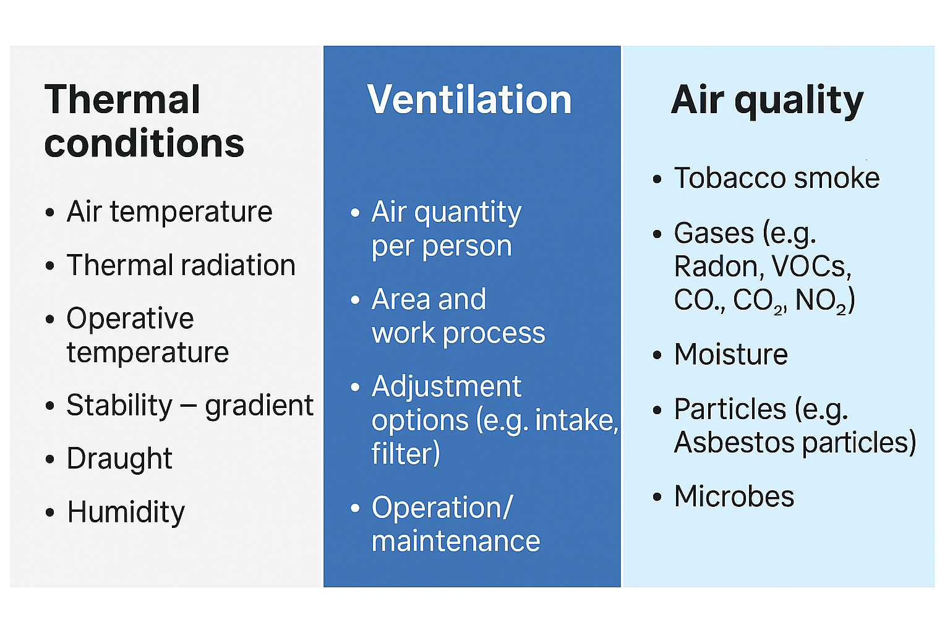
If the temperature in working locations exceeds 26°C due to process conditions, a risk assessment according to NS-ISO 7243 shall be performed and compensating actions applied. Further guidance on temperature considerations is given in Temperatur - varme og kulde på jobben

For a strategy and practical tools for assessing and managing cold risk in the workplace, refer to ISO 15743.

Radiation
Guidance on radiation is given by the Norwegian Labour Inspection Authority: Stråling and Arbeidsbygg skal forebygge sykdom og skade fra stråling, biologisk materiale og kjemikalier.

Project deliverables
Main deliverables are outlined in Table 10.

Table 10 Radiation hazards - recommended project deliverables
Radiation hazards – Recommended project deliverables
Feasibility
Concept | Identification of potential for exposure radiation and EMF.
FEED / Preparation for execution | Sources of ionising and non-ionising radiation shall be identified and risk-assessed.  Evaluation of mitigating actions.
Detailed Engineering  Execution | Sources of ionising and non-ionising radiation shall be identified and risk-assessed.  Evaluation of mitigating actions.
Construction/ Commissioning | Compile inventory of radioactive sources.
Operation | Conduct final inspections and verification measurements to ensure the installations meet the requirements

Project requirements
The design shall ensure that radioactive sources can be safely transported, handled, stored and disposed of.
The design shall ensure that sources of ionising radiation do not expose personnel to exposure levels which exceed the dose limits for occupational exposure; see Chapter 4 in Forskrift om tiltaks- og grenseverdier.

Several international and national standards regulate exposure to electromagnetic fields, including ICNIRP (International Commission on Non-Ionizing Radiation Protection) guidelines and EU directives on electromagnetic fields. These regulations set limits on exposure to protect human health and safety. The design requirements must therefore comply with these standards to ensure compliance and reduce the risk of negative health effects.

Annex A HRA (excel)
See separate Excel file for example of HRA method.

Annex B Risk Assessment Methods
Ergonomic risk assessment methods
Detailed risk assessment Recognised tools and methods
- KIM LHC: Lifting, Holding and Carrying of loads ≥ 3 kg
- KIM PP: Manual Pushing and Pulling of loads KIM-PP
- KIM MHO: Manual Handling Operations
- KIM BF: Body Force
- KIM ABP: Awkward Body Postures
- KIM BM: Body Movement
Tools are available here: Ergonomi - Offshore Norge
Sommer Energi, appropriate tools for risks 2023.10.25 Ergonomic risk assessment tools digitalized.xlsx

Chemical exposure risk assessment methods
The chemical risk assessment and verification is described in Chapter 3 ‘Forskrift om utførelse av arbeid, bruk av arbeidsutstyr og tilhørende tekniske krav (forskrift om utførelse av arbeid)’
Recognised methods and tools shall be used for detailed assessments. For the major chemical inventory system, a method for risk assessment is included (EcoOnline, Chemsoft etc).
For further guidance, refer to the Norwegian Labour Inspection Authority, Kjemikalier.

Biological risk assessment methods
The biological risk assessment and verification is described in Chapter 6 ‘Forskrift om utførelse av arbeid, bruk av arbeidsutstyr og tilhørende tekniske krav (forskrift om utførelse av arbeid)’
For further guidance refer to the Norwegian Labour Inspection Authority, Biologiske faktorer.

Lighting risk assessment method
The lighting risk assessment should identify lighting requirements for the work tasks to be performed. A good visual environment is characterised by:
- Enough basis illumination to allow people to notice hazards and assess risks
- A task illumination level appropriate for the type of work to be performed
- No excessive differences in illuminance between adjacent areas
- Without glare and veiling reflections
- No flickering and stroboscopic effects

To achieve good lighting at the workplace, it is necessary to satisfy:
- Visual comfort, which contributes to the workers’ feeling of well-being.
- Visual performance, which contributes to the workers being able to concentrate better and perform their visual tasks over a longer period.
- Safety, where proper lighting contributes to a better perception of potentially hazardous situations.

For further guidance refer to the Norwegian Labour Inspection Authority, Belysning.

Annex C Norwegian regulations

Summary of where regulations impact working environment factors
A non-complete summary of how some working environment-related acts and regulations are relevant for working environment factors is given in Table 11. This table is for guidance only, refer to The Norwegian Labour Inspection Authority for comprehensive information.
Table 11 Working environment regulation and working environment factors matrix
Working Environment Factors | Working Environment Act  Arbeidsmiljøloven (AML) | Planning and Building Act  Plan- og bygningsloven (PBL) | Building Technical Regulations  Byggteknisk forskrift (TEK17) | Construction Client Regulations  Byggherreforskriften | Regulations relating to Systematic Health, Environment and Safety Activities in Enterprises (Internal Control Regulations)  Internkontrollforskriften | The Workplace Regulations  Arbeidsplassforskriften | Regulations concerning the performance of work, use of work equipment and related technical requirements  Forskrift om utførelse av arbeid | Regulations concerning action and limit values for physical and chemical agents in the working environment and classified biological agents (Regulations concerning Action and Limit values)  Forskrift om tiltaks- og grenseverdier | Regulations concerning Organisation, Management and Employee Participation  Forskrift om organisering, ledelse og medvirkning
Climate, Ventilation and Air quality | - Indoor climate design (§ 4-4). | - Technical requirements (§ 29-5). | - General requirements for ventilation (§13-1).  - Indoor thermal climate (§13-4) | - Plan for climate, ventilation and air quality (§ 8). | - Ventilation (§5). | - Recirculation of air ventilation systems (§ 7-2).  - Requirement for climate, ventilation, air quality (§2-14) | - Risk assessment of health hazards associated with the use and handling of chemicals (§3-1).  - Hot work (§5) |  | - Risk Assessments (§7)
Noise and vibration | - Limit exposure to harmful noise (§ 4-4). | - Impact assessments(§4, 14). | - General requirements for sound and vibrations (§13-6)  - Room Acoustics (§13-8). | - Plan for noise and vibration (§ 8).  - Preventive measures for noise reduction (§ 9). | - Noise measurements and exposure (§ 5). | - Requirements for noise and vibrations (§ 2-16). | - Work that can entail exposure to noise or mechanical vibrations  (§14). | - Noise (§2)  - Vibration (§3) | - Risk Assessments (§7)
Ergonomics and workplace | - Ergonomic workplace design (§ 4-4). | - Consideration of workplace function in building planning (§29-5). | - Requirements for layouts (§12-5).  - Building components incl. doors, gates, stairs, railings, ramps and ladders (§12-15 to §12-20) | - Plan for work which entails a risk of harmful ergonomic burdens (§ 8). | - Ergonomics (§ 5). | - Requirements for design of workplaces, chairs and tables (§ 2-2 and §2-3). | - Requirements for the use of work equipment (§10):  - Facilitating the use of work equipment  - Choice and use of mechanical and electrical equipment (§11-3)  - Risk assessment in connection with planning, design and execution of manual work (§23-1) |  | - Risk Assessments (§7)  - Planning, facilitation of the work and safe operations  - (§10-2, §10-3)
Chemical and biological exposure | - Risk assessment and training for employees – particularly regarding chemical and biological health hazards (§ 4-5). | - Requirements for storage and security of buildings (§28-1). | - Requirements for technical solutions for waste management (§ 15-5).  Construction moisture (§13-14). | - Plan for hazardous exposure, chemical and biological (§ 8).  - Demarcation and laying out of areas for storage of various materials, particularly hazardous materials or substances (§9)  Storage, handling and removal of waste and hazardous materials (§9) | - Requirements, chemical and biological (§ 5). | - Chemicals and pollutants in the working atmosphere (Chapter 7).  - Work in surroundings that may entail exposure to biological agents (Chapter 8). | - Requirements for work involving chemical and biological risk factors (§2)  - Work where chemicals may be a risk to the health and safety of employees (§3)  - Work with asbestos (§4)  - Work in surroundings that may entail exposure to biological agents (§ 6)  - Work with cytostatics (§9) | - Chemicals (§5)  - Biological agents (§6)  - Work where there is a risk of reproductive harm (§7)  - Work at wastewater treatment plants (§8) | - Risk Assessments (§7)
Illumination | - Physical Working Environment (§ 4-4). | - Proper indoor environment (PBL § 29-5). | Illumination (TEK17 § 13-7). Views (TEK17 § 13-8). | - Plan for illumination § 8). | - Illumination levels (§ 5). | - Requirement for Lighting and day light (§2-10) | - Requirements for the use of work equipment (§10) |  | - Risk Assessments (§7)
Radiation | - Physical Working Environment (§ 4-4). | -  - Proper indoor environment (§ 29-5). | Radon (§13-5). | - Plan for radiation (§8). | - Mapping of Radiation (§ 5). | - Requirement for radiation (§2-15). | -Requirements for ionising radiation  and artificial optical radiation (§15 og §16) | - Radiation (§4) | Risk Assessments (§7)

Regulations
The Planning and Building Act (Plan- og Bygningsloven, PBL) is a key law in Norway governing land use and setting requirements for all types of construction projects. Part four outlines application procedures and processing. The PBL forms the legal basis for the Building Technical Regulations (TEK17). Building Acts and Regulations - Direktoratet for byggkvalitet

The Building Technical Regulations (Byggteknisk forskrift, TEK17) set out the technical standards required for legal construction in Norway, ensuring buildings meet the criteria for quality, accessibility, safety, environment, health and energy.
A building permit requires documentation that the project meets all requirements in laws, regulations and plans.
The Working Environment Act (Arbeidsmiljøloven, AML) is a key Norwegian law designed to ensure a safe, healthy, and meaningful workplace, protecting employees from physical and psychological harm.

Pursuant to Section 18-9 of the Working Environment Act, developers must obtain consent from the Norwegian Labour Inspection Authority for projects requiring an application pursuant to the Planning and Building Act that will include workplaces. This application must show that the workplace will protect employees' safety, health and welfare. Municipalities cannot issue a commencement permit until this consent is granted.
The law is supplemented by four main regulations that outline detailed requirements for health, safety and the environment.

Regulations on Organisation, Management, and Employee Participation ( Forskrift om organisering, ledelse og medvirkning) set out general requirements for most businesses, including employee and representative involvement, safety delegates, working environment committees, risk assessments, training, information, occupational health services and health monitoring.

The Workplace Regulations (Arbeidsplassforskriften) require that the physical conditions of workplaces are safe and suitable. They set standards for building design, outdoor work areas, access routes, storage and staff facilities. The regulations also cover safety equipment, signage, hazardous areas, chemicals, pollution and exposure to biological agents.

Regulations on the Performance of Work (Forskrift om utførelse av arbeid) set standards for work execution, equipment use and technical requirements. They cover work involving chemical, biological and physical risks, as well as other hazardous activities like manual labour, safety monitoring, diving and mining. The regulations require risk assessments, employee training and maintaining records of workers exposed to hazardous substances, biological agents and radiation.

Regulations on Action and Limit Values (Forskrift om tiltaks- og grenseverdier) supplement the requirements in the Regulations on the Performance of Work.
In addition to these, the following two regulations, also enforced by the Norwegian Labour Inspection Authority, will be significant in the planning and execution of a construction project:

The Internal Control Regulations (Internkontrollforskriften), also known as the HSE Regulations, set requirements for systematic HSE (health, safety and environment) work (internal control) and cooperation with employees and their representatives.

The Construction Client Regulations (Byggherreforskriften)
Regulate safety, health and working environment (SHA) during the planning, design and execution of construction and civil engineering work. The regulations describe roles, responsibilities and tasks for which the construction client is responsible, and are intended to ensure safety, health and working environment are safeguarded in all phases of a project, in conjunction with other HSE regulations. The Construction Client Regulations are based on the Planning and Building Act/TEK17, the Working Environment Act and the associated working environment regulations. The requirement to identify and assess risk is central to the Construction Client Regulations. When assessing whether a risk is acceptable, it is often necessary to refer to either TEK17 or the working environment regulations.
REACH Regulation
REACH is a European regulation intended to ensure the safe provision of information and knowledge about chemicals from manufacturers, and to and from end users of chemicals.

Consent applications
Two applications related to the working environment can be required and are shown in Table 12.
According to §18-9 of the Working Environment Act, project owners are obligated to apply to the Norwegian Labour Inspection Authority for consent in advance if both of these conditions are met:

- You are to change the use, construct a building or carry out structural work that is subject to application pursuant to the Planning and Building Act.
- And: The building is to be used, or is likely to be used, by an activity covered by the Working Environment Act.

Guidance for application is given in: Byggesak – søk om Arbeidstilsynets samtykke.

Pursuant to the EU REACH Regulation, it is a general requirement that manufacturers, importers and downstream users shall ensure that the substances they manufacture, place on the market or use do not adversely affect human health or the environment.

In addition to that, companies that use, or place on the market, certain substances of very high concern (SVHC) may need ‘Authorisation’ to do so. The aim of Authorisation is to ensure that the risks from SVHCs are properly controlled and that these substances are progressively replaced by suitable alternative substances or technologies where these are economically and technically viable.

Authorisation can be granted for ‘specific uses’ by the European Commission on the basis of an ‘application for authorisation’ made to the European Chemicals Agency (ECHA). Where an authorisation is granted by the Commission, it is valid until amended or withdrawn, but is subject to time-limited ‘review’, at which time authorisation holders are required to submit a review report.

Table 12 Working environment related consent applications
 | Application | Authority | Act/Regulation | Comments/ Status
1 | Concent for erection af new buildings etc. | Norwegian Labour Inspection Authority | Working Environment Act, §18-9 | Prior to start of construction. The consent must be approved by the Norwegian Labour Inspection Authority prior to issuance of the commencement permit from the municipality  Link to “Byggesak” (Norwegian only)
2 | Apply for authorisation to continue or start using and placing substances included in the Authorisation List on the market | The European Chemicals Agency (ECHA) | Annex XIV of REACH | Prior to start of using a substance  Link to ECHA

